SDC Meeting - 3 May 2016

- Database: Jimmy put data into the database and showed how tokens could be queried directly
  - Discussion about data cleaning and what fields would need to be added to the data in python before importing from Python to the database.
    - Extra fields required include borough and ward
  - Check that we have got the output from the python importing directly into the database.
- Website Design: Quiling showed start of the website layout and it looks like a good start.
  - Don’t need a separate label for interactive visualization
  - Suggestion that website content pop out in a second column to allow for more space.
  - Filters on the right side with a box for borough statistics to appear underneath
  - Description of home page to come up immediately
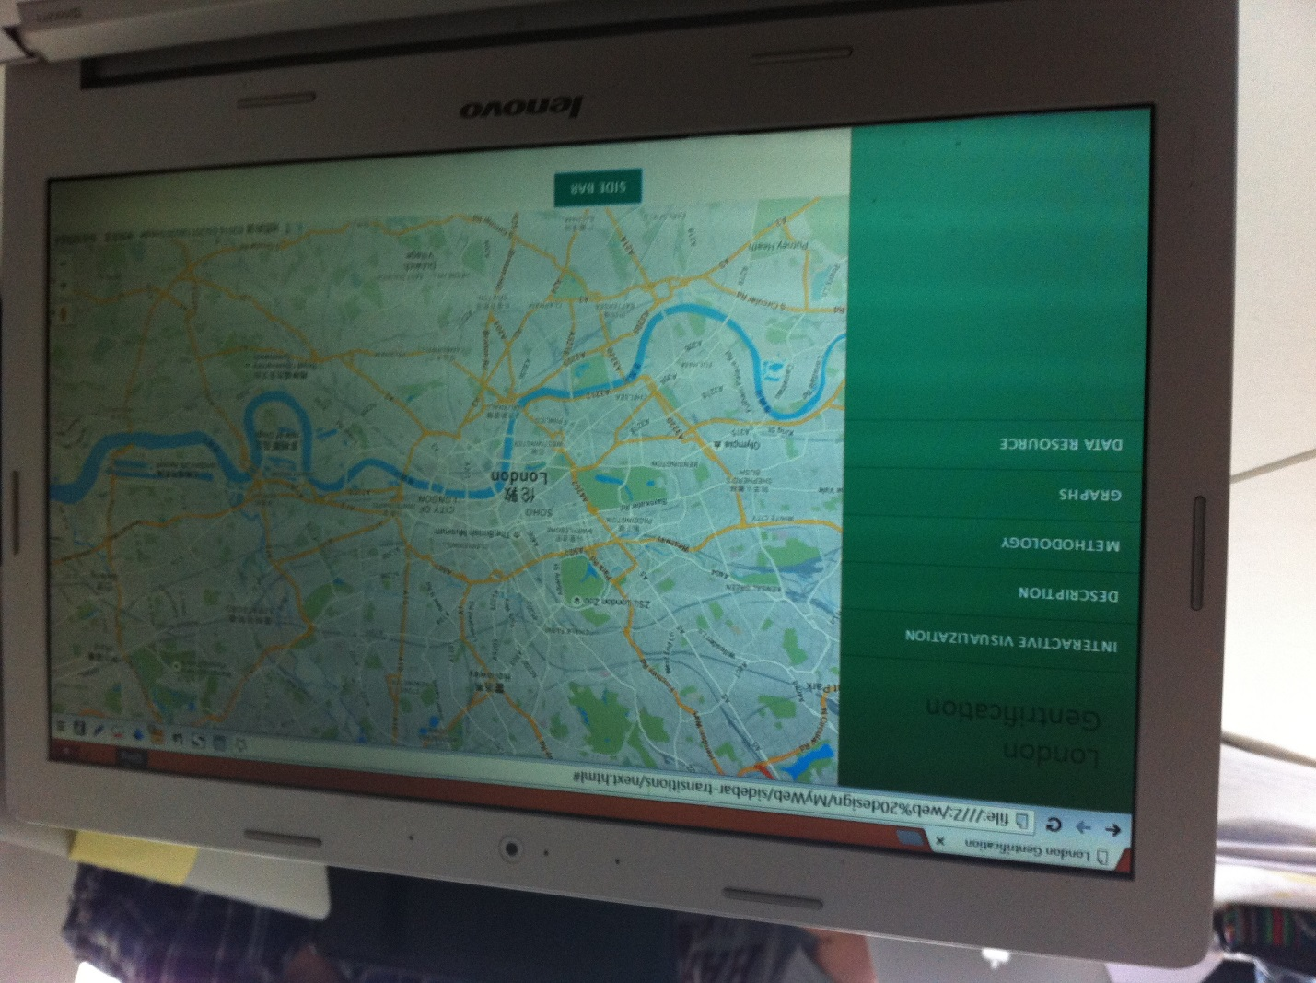

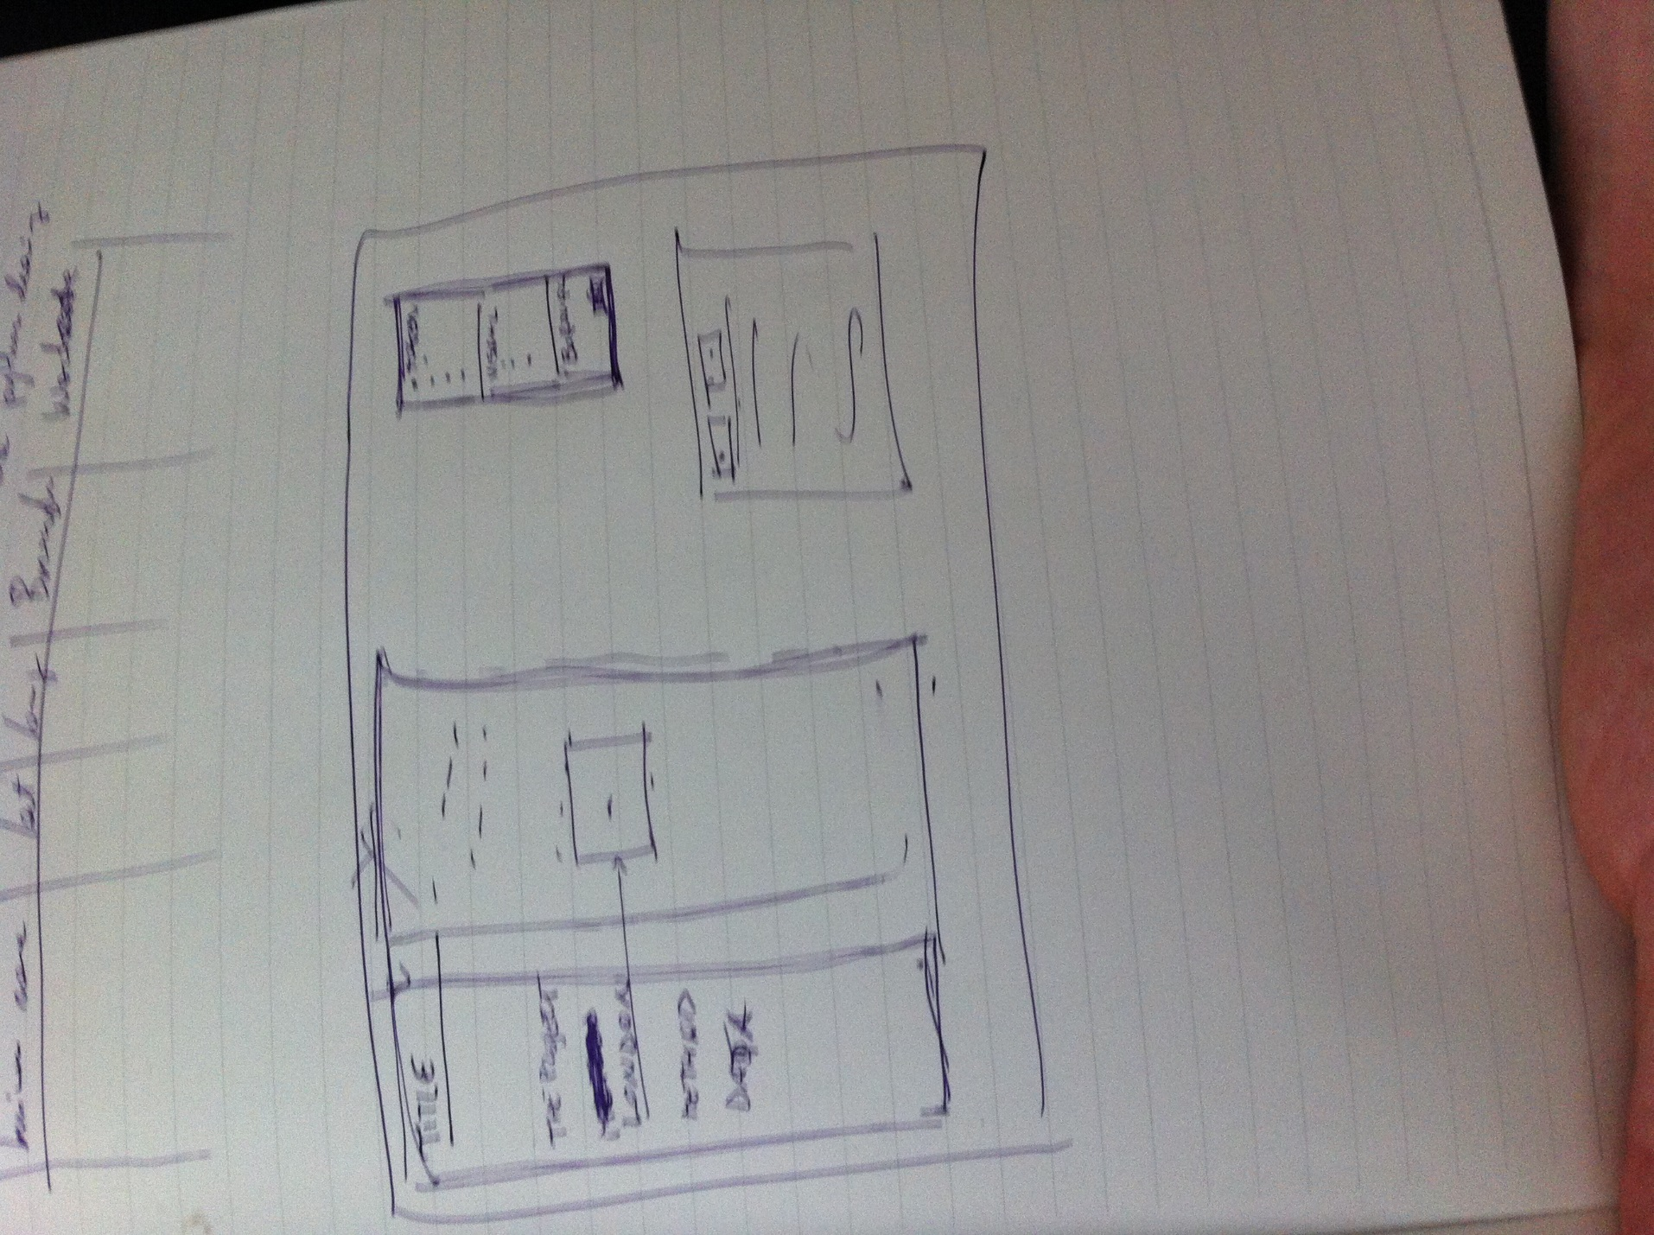
- Analysis: to include correlation, WGDAL, location quotient etc.
Timeline:
- Friday 6th May - Jimmy to have database content with boroughs and wards uploaded by
- Friday 6th May - Group to work on joining up database to map on during class time
- Wednesday 11th May – Website with dot density map to be working.
- Wednesday 11th May – Work on including a python script on server.
- Friday 13th May – first stage with map, API, python working, ability to zoom to a ward.
- Friday 20th May – All other layers added to the map – Basic Website complete
- Final week – Finishing touches, any extra functionality, presentation and individual reports to be completed.
Jimmy – Get stuff in database and share server login details with group
Quiling – Continue setting up website structure
Duccio – Learn how the API works
Claire – Code python functions

